**Credit Card Fraud Detection using machine learning**

This project is about detecting fraudulent transaction that are done through credit cards. I have created a machine learning web app which will take transaction details from the user and our model will predict whether the transaction is legitimate or fraudulent.

**Problem Statement**

Fraud detection is a set of activities undertaken to prevent money or property from being obtained through false pretences. Fraud detection is applied mainly to Banking Finance Service Industry and can be used by Bank, and Insurance companies. In banking, fraud could be by forging checks or by stealing credit cards. With increase in digitalization, fraudulent activities are increased and happening in various domains such as retail domain. This will make a dent on the online transactions ecosystem so we are proposing this solution to increase the security and safety of the monetary transactions.

**Authors**

* [Sandeep Kashyap](https://www.github.com/sandy252)
* [Gourav Rishi](https://www.linkedin.com/in/gouravrishi/)

**Proposed Solution**

With the help of machine learning we attempt to recognise the fraudulent credit card transactions so that customers will not be charged for items that they have not purchase.

**Features**

* Manual insertion if fraud is identified
* Detection of upcoming frauds
* Gives better insight of customer base.
* Prevents customer from falling on fraud traps.

**Dataset**

The dataset is taken from a kaggle problem statement. You can download the dataset from [here](https://www.kaggle.com/mlg-ulb/creditcardfraud)

**Approach**

* Data Exploration: Exploring dataset using pandas, numpy, matplotlib and seaborn.
* Data visualization: Plotted graphs to get insights about dependent and independent variables.
* Feature Engineering: Removed missing values and created new features as per insights.
* Feature Selection: Removed all the unwanted/ non-significant feature using selectKbest.
* Model Selection I: Tested all base models to check the base accuracy. Also plotted and calculate Performance Metrics to check whether a model is a good fit or not.
* Pickle File: Selected model as per best accuracy and created pickle file using pickle library.
* Webpage & deployment: Created a web form that takes all the necessary inputs from user and shows output.

**Technologies Used**

* Pycharm Is Used for IDE
* For Visualization Of The Plots Matplotlib , Seaborn Are Used
* AWS and Heroku is Used for Model Deployment
* Mongodb Database is used as Database
* Front End Deployment Is Done Using HTML, CSS
* Flask is for creating the application server and pages
* Git Hub Is Used as A Version Control System
* os is used for creating and deleting folders
* csv is used for creating .csv format file
* numpy library is for arrays computations and mathematical operations
* pandas library is for Manipulation and wrangling structured data
* scikit-learn library is used for machine learning tool kit
* Logistic Regression model is used for training the model
* pickle is used for saving the model

**User Interface**

* Home Page

[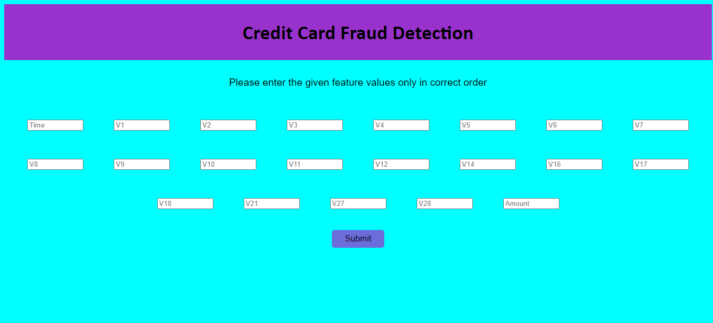](https://user-images.githubusercontent.com/66490787/134642251-4598e41d-ea87-4d53-97b0-6ef51a3b500b.png)

* Prediction page

[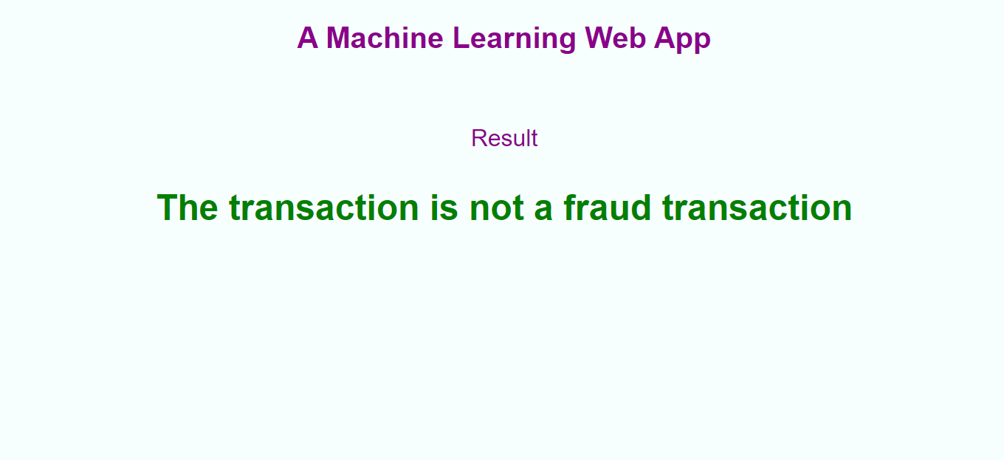](https://user-images.githubusercontent.com/66490787/134642300-c6ddd820-bde2-414e-a17f-90b5e6cc19fc.png)

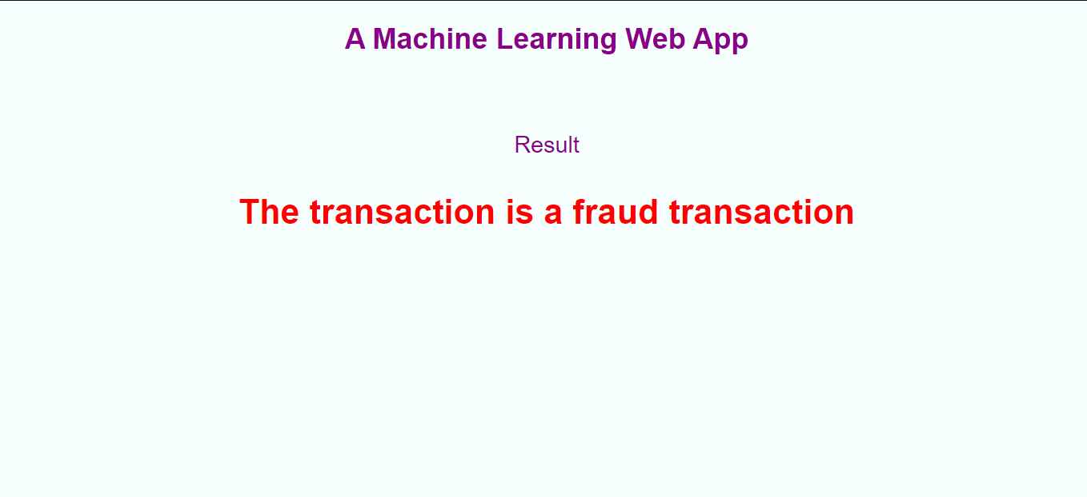

**Demo Video**

**Deployment Link**

[https://fraudtrasactiondetection.herokuapp.com](https://fraudtrasactiondetection.herokuapp.com/)

**Run Locally**

* clone the project
* traverse to project directory
* Install dependencies

pip install requirements.txt

* Run the app.py

python app.py

**Support**

For support , email @ [kashyapsandeep252@gmail.com](mailto:kashyapsandeep252@gmail.com) or [dtu.gourav@gmail.com](mailto:dtu.gourav@gmail.com)

**Documentation**

* [Detailed Project Report](https://drive.google.com/file/d/1W48MK9WrmGFU18HWjxumkSk5bCfwNJEG/view?usp=sharing)
* [High Level Design](https://drive.google.com/file/d/17H0KBBAsrmbosJ60LPqapOzjYhSjCPEN/view?usp=sharing)
* [Low Level Design](https://drive.google.com/file/d/1PRRzUEhL5l7NO5XO8-ksmk4BZ71NiROh/view?usp=sharing)
* [Architecture](https://drive.google.com/file/d/1xiNJTuPKLFnT8Ewj9LE9ie2gLMM818rB/view?usp=sharing)
* [Wireframe](https://drive.google.com/file/d/1wt12CYrzoVMnklyMbMouazRLK35fWD9d/view?usp=sharing)